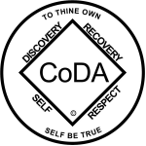

CoDA Service Conference 2017

Motion Form

Committee: Literature Date: August 5

Motion Number: One

Result___________________

Motion:

We move that whenever a service item (new or revised) is endorsed by CoDA Service Conference, that the Service Structure Committee is directed to incorporate any new or revised service piece into the appropriate section of the FSM, replacing the earlier version.

________________________________________________
Intent:

Prompt updating of service items

________________________________________________
Remarks:

Last Revised 8/7/2016

