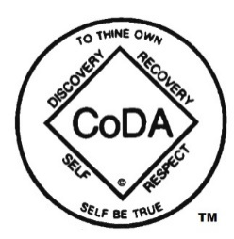

CoDA Board of Trustees
Minutes, 7th face to face meeting
Saturday, July 25, 2020

Attending: Don B/SoCal, Salle/NorCal, Yaniv S/Israel, Linda A/NorCal, Nancy O/Canada
Consent Agenda – There were no Consent Agenda Items
Old Business
Motion to approve Minutes of meeting of July 11, 2020 was passed unanimously
Nancy moved to approve the Board’s budget submission for next year. Don seconded, and motion was unanimously approved as submitted by the Treasurer.
After those present edited the Board’s Annual Report, Nancy moved to approve it. Don seconded, and the motion was unanimously approved.
The PowerPoint presentation of the Board’s Annual Report was edited by those present. A motion to accept it was unanimously approved.
New Business
Nancy moved to accept Gail S and Yaniv S, Alternate Trustees, as full Trustees of the CoDA Board. Salle seconded. All agreed.
Reviewed the draft of the 2020 CSC Schedule. Discussed a need to convey to the Fellowship that the agenda is stripped down this year in view of the new format. Linda to work on this.
New Items proposed for the website’s meeting search capacity will cost less than $270. As that falls within the $3500 already approved for these improvements, no further action is needed to start this work.
The Board Treasurer, Salle apprised the Board of some misinformation going around, that PayPal contributions to CoDA, Inc. can be reassigned to some other CoDA entity (e.g., an intergroup). The Treasurer explained that no such redirection of funds donated to CoDA, Inc. is possible.
The Board considered the Voting Entity Item from the UK that did not meet the CSC’s deadline for motions. Nancy will draft a reply.
After this meeting there will be a meeting to review proposed mockups of additional search features for CoDA’s Meeting Database.
Next meeting
Due to the CoDA Service Conference, there will be no Public Board Meeting during August.
Next Workgroup Meeting - August 8

