Co-NNections “Words Of Wisdom” bookmark

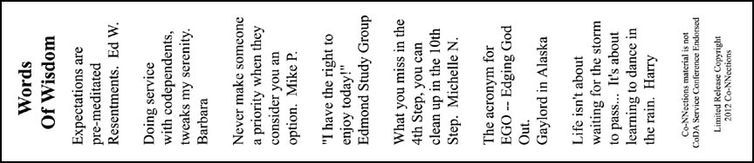

Download Front Download Back

