CoDA Service Conference 2021
Motion/Voting Entity Issue (VEI) Form

Check one: _X_Motion Board
__ VEI (See VEI Guidelines on reverse side of this form)

Committee Name: Board_____
Date: May 8, 2021 Assigned Number: Motion 2___
Revision #: Revision Date: ___________

Motion Name: CoDA Service Structure Chart
Motion/Issue: Move that the Co-Dependents Anonymous (CoDA) Service Structure chart of the inverted pyramid revert to the chart used by CoDA from 2005-2016 as in Figure 1 below.
Intent, background, other pertinent information:
The CoDA Service Structure diagram that is currently displayed in the Fellowship Service Manual, Part 1, Page 12 as shown below as Figure 3 has never been approved by Conference. Also, in the absence of a binding vote on Adhoc Motions 20030 and 20031 at the 2020 CSC, there is no consensus supporting a change to the inverted pyramid charts presented in either motion.

Remarks and Background
The structure chart shown in;
Figure 1: was successfully used by CoDA from 2005-2016.
Figure 2: In 2017, the structure chart was changed as shown, when the entire Fellowship Service Manual revision was approved by SSC Motion Number 17006.
Figure 3: Then in 2018, a new structure chart mysteriously appeared in the approved 2018 FSM. No conference approved motion or otherwise has been located to justify this new chart.
The unapproved new chart has created a controversial and artificial separation between the responsibilities of the CoDA Board of Trustees and CoDA, Inc. the Corporation.

The Adhoc Committee Structure 2 Motion presented at the 2020 CSC was based on the premise of this unapproved separation of the CoDA Board of Trustees and CoDA, Inc. responsibilities. At the 2020 CSC, the Board objected to this separation of responsibilities and requested the Service Structure Committee to provide the Motion Number that approved the structure chart as shown in Figure 3. SSC was unable to provide the motion number, nor has the Board been able to locate any such motion.

The Board of Trustees asks conference to return the CoDA service structure chart to the one as shown in Figure 1 since it has served the Fellowship well for at least 11 years. The Board argues that the chart approved by conference in 2017 as shown in Figure 2 did not receive the attention it deserved because of the confusion surrounding the complete revision of the FSM at the 2017 CSC, and that it does not best represent the CoDA service structure.

This motion or VEI requires changes to: (please check any that apply)
____ By Laws _X_ FSM P1, Pg 12 ____ FSM P2
____ FSM P3 ____ FSM P4 __ FSM P5
____ Change of Responsibility
____ Other: Committee and Board action

(Data Entry Use Only)

Motion result: _______________________________________

Guidelines for Presenting Voting Entity Issues to CSC

- Local Voting Entity discusses an issue and forms a recommendation to resolve that issue by using the group conscience process. This issue and recommendation is called a Voting Entity Issue (VEI)
- Voting Entity drafts the VEI, completes the VEI form, and sends it to the Board of Trustees via VEI@coda.org. From this point of submission, all email communication concerning the VEI from all parties must copy VEI@coda.org.
- Board sends email confirmation acknowledging receipt of the VEI to the Voting Entity within 14 days.
- Voting Entity Issues (VEI) may be submitted at any time of the year. Submission is not limited to the CSC
submission deadline.
- Board assigns the VEI to either the board or the appropriate committee within 30 days of acknowledging receipt of VEI. Board notifies the VE at the time the VEI is assigned.
- Assigned Board or committee examines the issue and through group conscience, develops a response or written plan to address or resolve the VEI within 90 days of being assigned. During the response/plan development, it’s important that the assignee and the VE collaborate, communicate transparently, and work together towards a mutually agreeable plan, in service to the VE.
- The VEI may not dishonor or be in conflict with any By-laws, Steps, Traditions or legal considerations. If so, in it’s written response, the assigned Board or committee must cite specific reasons for the conflict.
- Assigned Board or Committee, in collaboration with the VE, may develop a motion to be presented at the CSC.
- In the event the VE is not satisfied with the response or plan from the Board or assigned Committee, the VE retains the right to draft and submit a motion to the next CSC using the electronic motion form available on the CoDA website. The motion must not dishonor any by-laws or legal considerations, and must meet all criteria for presenting a motion. (See procedures for submitting CSC items in part 4 of the FSM). The VE may request assistance from the IMC in drafting and presenting the motion.
- The Issues Mediation Committee (IMC) will monitor the progress of the VEI to ensure the process is being followed and the timelines are being met.
- The VE Delegate is responsible for following up on the status of their Voting Entity issues and reporting back to their membership.

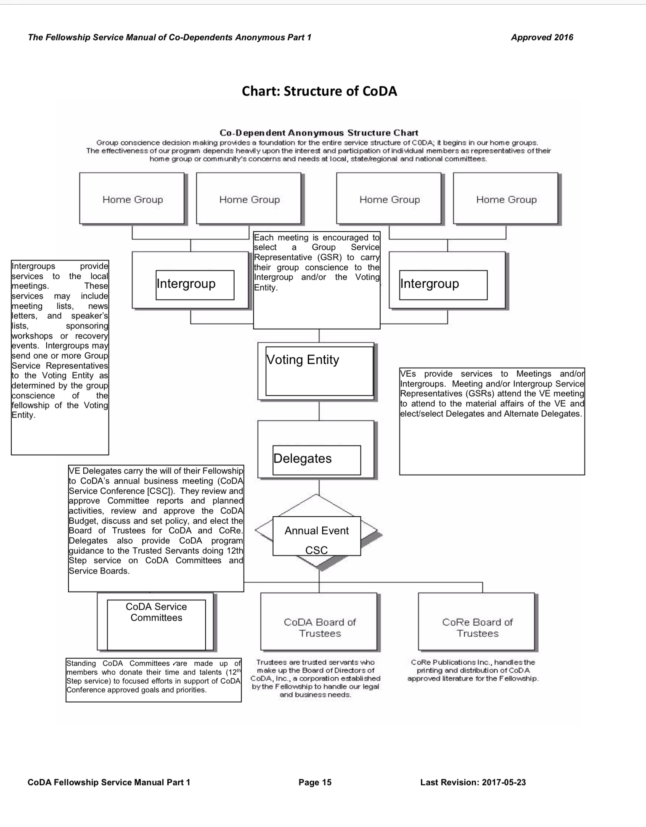
Figure 1: was successfully used by CoDA from 2005-2016.

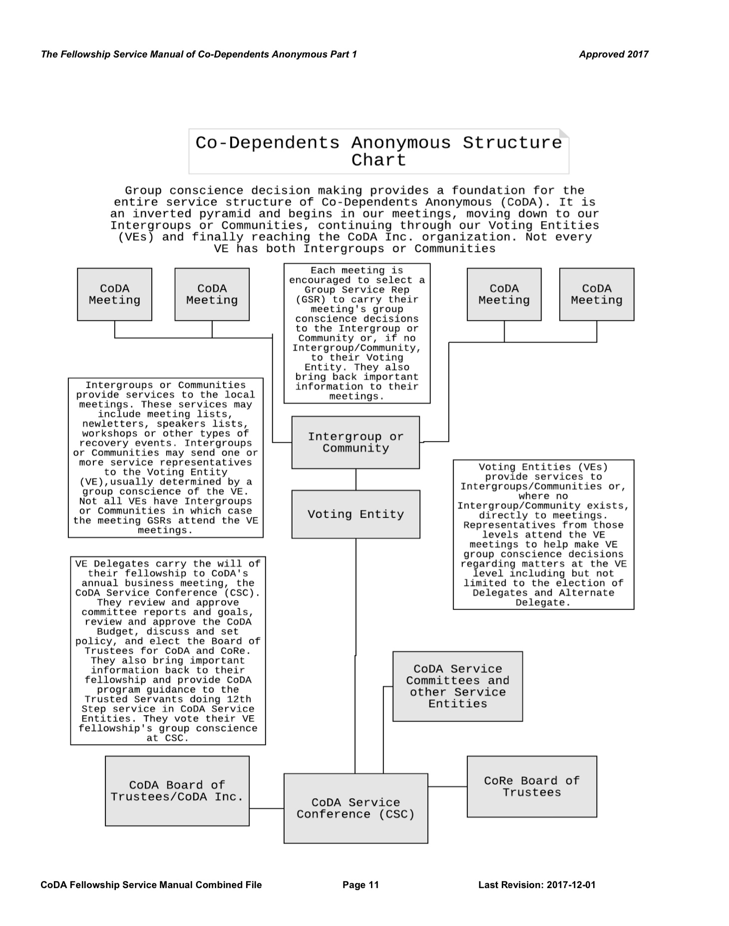
Figure 2: In 2017, the structure chart was changed as shown, when the entire Fellowship Service Manual revision was approved by SSC Motion Number 17006.

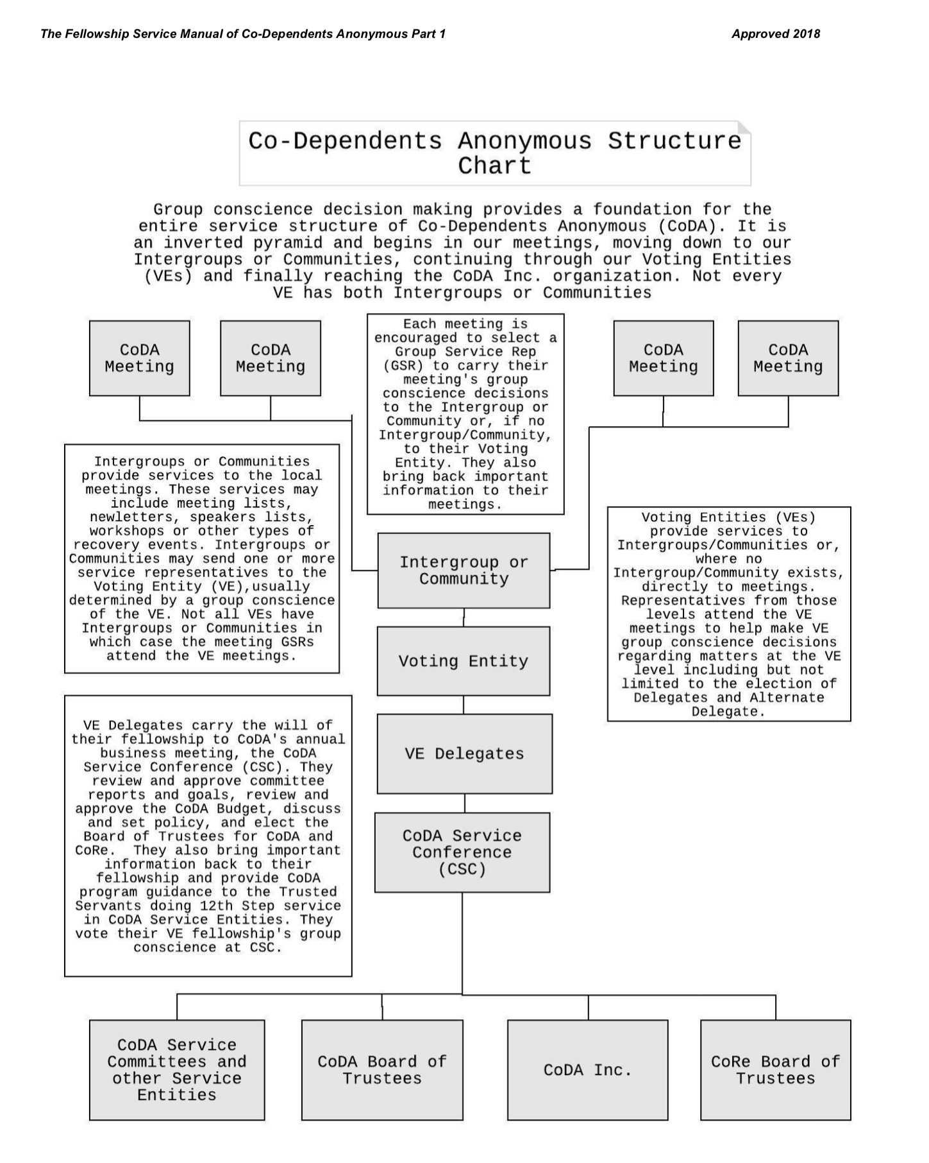
Figure 3: Then in 2018, a new structure chart mysteriously appeared in the approved 2018 FSM. No conference approved motion or otherwise has been located to justify this new chart.

