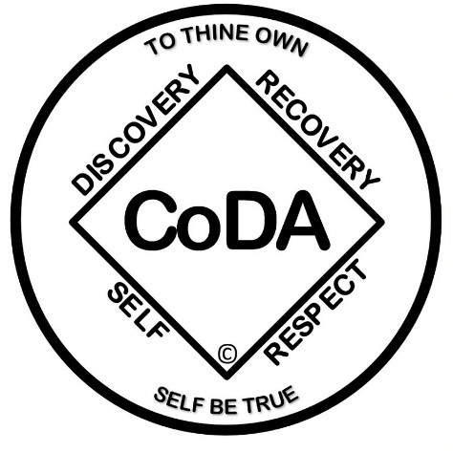

The Twelve Traditions of CoDAteen©*
- Our common welfare should come first; personal recovery depends upon CoDAteen unity.
- For our group purpose there is but one ultimate authority: a loving Higher Power as expressed to our group conscience. Our leaders are but trusted servants; they do not govern.
- The only requirement for membership in CoDAteen is a desire for healthy and loving relationships.
- Each group should remain autonomous except in matters affecting other groups or CoDAteen as a whole.
- Each group has but one primary purpose: to carry its message to other CoDAteens who still suffer.
- A CoDAteen group ought never endorse, finance, or lend the CoDAteen name to any related facility or outside enterprise, lest problems of money, property, and prestige divert us from our primary spiritual aim.
- Every CoDAteen group ought to be fully self-supporting, declining outside contributions.
- CoDAteen should remain nonprofessional forever, but our service centers may employ special workers.
- CoDAteen, as such, ought never be organized; but we may create service boards or committees directly responsible to those they serve.
- CoDAteen has no opinion on outside issues; hence, the CoDAteen name ought never be drawn into public controversy.
- Our public relations policy is based on attraction rather than promotion; we need always maintain personal anonymity at the level of press, radio, films, television, and all other public forms of communication.
- Anonymity is the spiritual foundation of all our traditions, ever reminding us to place principles before personalities.

*The Twelve Traditions are reprinted and adapted with permission of Alcoholics Anonymous World Services, Inc.

