Check one:
CoDA ServiceConference(CSC)
2024 MotionForm

Motionsubmittedby:Board- CoDA Inc.

Motionsubmittedby:Board- CoDA ResourcePublishing(CoRe)

Motionsubmittedby:(Committee) CommitteeName:

x
Motion submitted by: Voting Entity (VE) NorCalCoDA

Submitted Date:May 8, 2024

IMPORTANTDEADLINES :
● Motionsaredue75 days priortoCSC whichfor thisyearisWednesday,2024 May 8.
● Bylawchanges/amendmentsaredue75 days beforeCSC whichfor thisyearis Wednesday,2024 May 8. Thesechanges/amendmentscannotbebroughttothefloorif thisdeadlinenotmet.In accordancewithour FellowshipServiceManual(FSM) and CoDA Bylaws, BylawamendmentsaretobesubmittedtotheBoardSecretary:
secretary@coda.org .
● Revisionsaredue60 days priortoCSC whichfor thisyearisThursday,2024 May 23.

MotionNumber:1. ( X )2. ( ) 3. ( ) 4.( ) 5. ( ) (CheckOne)

Revision#: one Revision Date: per board's request 6/28/2024

Note: PleaserefrainfromusingCoDA acronyms such as VE, CEC,IMC, etc.when completing thisformunless you makeareferencesuch as:CoDA EventsCommittee(CEC)thenuse CEC.

MotionName:

Form a “SpecialFellowshipMeeting”TaskForce

Motion–

Approve the formationofa task force todevelopa process for the “CoDA Fellowshipas a Whole”tocallfor a SpecialMeetingbetweenCoDA Service Conferences as referenced in the CoDA Bylaws, Article V,Section5.

TheTaskForce wouldhave oneyear tocreate the process for presentation at the 2025 CoDA Service Conference.

Prospective members ofthe task force couldpotentiallyincludea member from the CoDA Board ofTrustees,Issues MediationCommittee (IMC), Events, andthe Delegate RelationsCommittee (DRC) alongwithany current or former Delegate from a recognizedVotingEntity.

INTENT:

Toempower the Fellowship tocall a special meeting between the annual CoDA Service
Conferences toobtain group conscience forCoDA as a Whole. Tounite us - not divide us

BACKGROUND:

Currently,as mentioned in the CoDA ByLaws, there is the potential ability for the Fellowship tocall a special meeting ofthe Fellowship between CoDA Service Conferences.However, there is no actual process in place.

This TaskForce would seek todevelop a process todetermine a clear course ofaction and answer these questions:

● Whattodo if a CoDA member has an issue thatcannot be resolved with IMC or the Board and it affectsCoDA as a whole?
● How tobring thatissue tothe attention ofthe Fellowship?
● How would a VotingEntitybe involved?
● How would the Delegate Relations Committee (DRC) be involved?
● How toinitiate a petition?
○ from VEtoFellowship?
○ from DRC toFellowship?
○ from VEtoDRC toFellowship?
● How toget thatpetition out asking forsignatures from all delegates who attended last year's CSC?

● How tothen have the results ofthatpetition containing signatures from two-thirds ofthe delegates from last years’ CSC brought tothe attention ofthe CoDA
Board and IMC Committee and Delegate Relations Committee?
● How tohave the petition included in the motions tobe ratified atthe next year’s
CSC?
● Othersuggestions?

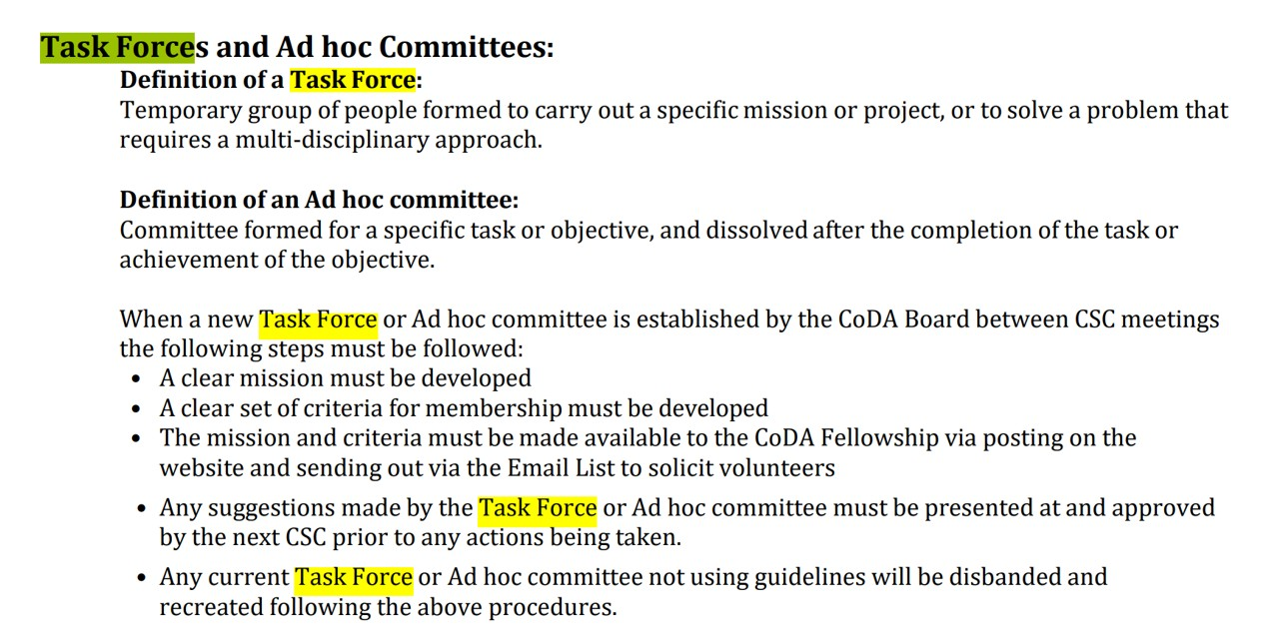

OTHER PERTINENT INFORMATION:

TraditionOnePrayer -
“HigherPower,deepenmy awareness toincludethe welfare ofthe whole,setting aside my discomfortandpersonalagenda.Helpme speak my truthandallow others the same privilege,trustingthat the spiritofunitysupportsmy own recovery.”

Remarks:

This motion offersan opportunity tocreate healthy strategies toaddress any possible concerns ofsituations happening in committees or boards atthe world service level.

The CoDA inverted pyramid ofCoDA clearly shows the VotingEntities (VE) are the voice ofthe smaller home groups and communities atthe top,with their purpose to bring thatgroup conscience tothe world service level.

This TaskForce would provide clarity defining action steps a VotingEntity(VE) may take in addressing concerns between annual CoDA Service Conferences (CSC). The TaskForce would also greatly appreciate and welcome input and participation from the Delegate Relations Committee (DRC) in exploring these strategies tosuccessfully complete the goals ofthis taskforce.

(Weask thatyou use themostcurrentFSM on coda.organdbeveryspecificwherethischange shouldbemadetoincludereferencestoacertainsentence,paragraph,etc.You maycopyand pastefromthecurrentFSM toensureaccuracyandindicateas “currentwording:”,thenlistthe changeor updateby indicating“newwording:”.)

This motion requires changes to the f ollowi ng: ( check allthatappl y)

CoDABylaws:Page/Section#
FSM Part1 – StructureandGeneralInformation:Section# FSM Part2 – MeetingHandbook:Section#
FSM Part3 – Guidelinesfor OtherServiceLevels:Section# FSM Part4 – ServiceConferenceProcedures:Section#
FSM Part5 – WorldLevelServiceDetails:Section# Changeof Responsibility:
Other:

Specific details:

Motions areto be sentto:submitcsc@coda.org
Bylawchanges/amendmentsaretobesentto:secretary@coda.orgIf you wantassistancewritingyour motion,pleasesendemailto
Board@CoDA.org

(DataEntryUseOnly)

Motion result:

