

**Check one:**

**CoDA Service Conference (CSC)**

**2024 Motion Form**

**Motion submitted by:** Board - CoDA Inc.

**Motion submitted by:** Board - CoDA Resource Publishing (CoRe)

**Motion submitted by:** (Committee)

Committee Name:

**x Motion submitted by:** Voting Entity (VE) NorCalCoDA

**Submitted Date: May 8, 2024**

IMPORTANT DEADLINES :

● Motions are due 75 days prior to CSC which for this year is Wednesday, 2024 May 8.

● Bylaw changes/amendments are due 75 days before CSC which for this year is Wednesday, 2024 May 8. These changes/amendments cannot be brought to the floor if this deadline not met. In accordance with our Fellowship Service Manual (FSM) and CoDA Bylaws, Bylaw amendments are to be submitted to the Board Secretary:

[secretary@coda.org](mailto:secretary@coda.org).

● Revisions are due 60 days prior to CSC which for this year is Thursday, 2024 May 23.

**Motion Number: 1. ( ) 2. ( ) 3. ( x ) 4.( ) 5. ( ) (Check One)**

**Revision #:**

**Revision Date:**

**Note:** Please refrain from using CoDA acronyms such as VE, CEC, IMC, etc. when completing this form unless you make a reference such as: CoDA Events Committee (CEC) then use CEC.

**Motion Name:**

**When Serving as a Board Member, Alternate, or Interim Board Member, Dual Roles and**

**Concurrent Positions at world service are not allowed**

**Motion –** to:

1. ADD this verbiage to the Fellowship Service Manual Part 5 at the end of Section 3: CoDA Standing Committees:

*“Effective with the conclusion of the 2024 CoDA Service Conference (CSC), a chair of a standing committee or any member of the Issues & Mediation Committee (IMC) may not serve as a Board Alternate or Interim Board Member unless they relinquish their position.”*

and

2. REMOVE this statement from the Fellowship Service Manual (FSM) Part 4 page

19-20: under the CoDA Board Alternate description:

*• Alternate Trustees can serve as CoDA committee members. If they become a Trustee, they must resign from the committee as a member but may participate as a Board Liaison.*

*• Alternate Trustees may serve as a delegate or officer at the level of Intergroup or Voting Entity. An Alternate Trustee will have no vote at Conference unless serving in the capacity of Delegate. If they become a Trustee they must resign as a delegate or officer.*

*.*

AND REPLACE WITH: (bold shows actual changes to be made to this section)

*● Alternate* ***and Interim*** *Trustees can serve as CoDA committee members* ***but cannot simultaneously serve as chair of a standing committee****. If they become a Trustee* ***or are able to vote at any time****, they must resign from the committee as a member but may participate as a Board Liaison.*

*●* ***Alternate and Interim Trustees may not serve as a member of the Issues & Mediation Committee (IMC). The IMC shall remain a neutral party.***

*● Alternate* ***and Interim*** *Trustees may serve as a delegate or officer at the level of Intergroup or Voting Entity. An Alternate Trustee will have no vote at Conference unless serving in the capacity of Delegate. If they become a Trustee****, or have the ability to vote at any time,*** *they must resign as a delegate or officer.*

**INTENT:**

**To clarify previously passed CSC motions 23019 and 19020 and 19018 (see motions referenced below under BACKGROUND)**

**And determine:**

**What is the definition of an interim board member? What is the definition of an alternate board member?**

**Are either of these positions voting as full board members?**

**BACKGROUND:**

It is well known that, as a full board member, one relinquishes their other leadership roles at the World level and the Voting Entity level.

Recently the Board voted to accept two new board alternate members midterm. They concurrently hold significant positions at the World level. One is a member of the Issues

& Mediation Committee and one is a Chair of a standing committee. While a Board alternate can continue as a general committee member, it was understood that a Board alternate is not to be Chair of a committee and serve in another position per motion

19020. The Board reviewed the previous CSC motions 19018 and 19020 and voted that because there was not wording that “specifically” mentions the Board, they voted that these motions only pertained to World committees and Voting Entity Delegates.

This practice has led to issues with conflict of interest within the Board and the committees. The IMC member//Board alternate has participated as a full Board member in place of the Board Secretary who has been on medical leave for over a month. This gives the appearance of a conflict with their duties as a member of IMC, this why dual roles are seen as problematic.

Also, the other Events Chair/Board alternate has filled in multiple times at meetings for a missing Board member, voting as a full Board member concurrently holding her position as chair of Events. Again this gives the appearance of a conflict in their duties as chair.

**OTHER PERTINENT INFORMATION:**

We request new interim/alternate board members resign from other currently held offices at Intergroup and Voting Entity level and any CoDA Committee/Task Force positions or membership to allow others the opportunity to give service and to create time to devote to Board work.

We appreciate the eagerness and desire to serve CoDA by holding multiple leadership positions. However the conference has previously passed motions with the intent that the Chair of a committee should not engage in activities on other committees (which includes the Board—as the Board alternate sits and has voice at all Board meetings) so that they can fulfill their role in guiding the committee. In the same vein, the Voting Entity Liaison has an important role in vetting and guiding the delegates, interfacing with the CSC prep group, the Board Secretary and the Events committee. Full attention should be given to our Voting Entity delegates.

**From the Issues & Mediation Commi t t ee ( IMC) Pol ici es An d Pro c e d u re s ( P**

**andP)**

2015 CSC: * Voting Entity Liaison (VEL) position was created at the CoDA Service Conference (CSC) to work with Voting Entities, Delegates, the Board Secretary, the Events and Finance Committees through the group conscience decision making process with the IMC

FROM IMC POLICIES and PROCEDURES -- Voting Entity Liaison (VEL):

A) Voting Entity Liaison (VEL) is a neutral party and may collaborate as needed in specific issues/mediations.

B) Vets VE delegates on behalf of their Voting Entity (VE) for: i) Confirmation as a Delegate for CSC and/or ii) Consideration for receiving a possible Delegate Grant to the Voting Entity (VE).

C) Tracks history of Delegate and Host Grants awarded on the SmartSheet web-based program

D) Serves as a liaison between the Board Secretary and Voting Entities: i) Confirmation of the vetted CSC delegates ii) Voting Entity contact list information via SmartSheet. E) Maintains a list of VE structure contacts.

**BACKGROUND:**

**Motions from 2023 CoDA Service Conference: MOTION DEFEATED**

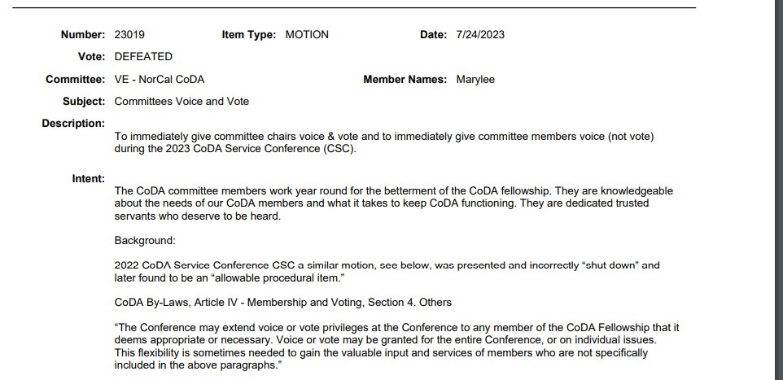

**Motions from 2019 CoDA Service Conference #1: MOTION PASSED 2/3 MAJORITY**

**Motion Date: 9/10/2019 Meeting Type: CSC Number: 19020 Board Number:**

Item Type: MOTION Member Names: Salle H Committee: Board

Subject: Board Motion #5 - **No Chair of Standing Committee on other**

**Committees**

Amends Motion Numbers: Vote: 2/3 Vote

Description: Move that no chair of a standing committee may serve as a full member on other standing committee.

Intent: Remove the conflict of interest involved in serving on multiple committees while also chairing a committee. Insure that every Chair meets the requirements of that primary role of guiding a committee.

Remarks: FSM, part 1, shows the responsibility of a chair for the committee’s work: “By tradition, the CoDA Service Conference gives responsibilities to working committees composed of Conference Delegates and other CoDA volunteers or to separate service boards or corporations. All are directly responsible to the Conference. The scope of the work a committee does is determined by the Conference group conscience. The chairperson of each committee assumes the responsibility to ensure the work assigned to the committee is completed in a timely manner.” (page 9)

This motion requires changes to: X FSM P1 - pg. 9; X FSM P3 - sect. 5, p. 10, 12-13, p.

20; X FSM P5 - pg. 7

******* QUESTIONS - yes PROS & CONS -

Pros - 3 - have been in this position, thinks its a good idea; can take care of confusion if there is too much overlap; allows more people in service

Cons - 2 - against motion because the individual can determine if they can handle two rolls; against if "standing committee" isn't added at the end of the motion.

CRAFTING - yes

VOTE: 34 Yes, 6 No, 2 Abstention - **motion passes with 2/3rds majority**

Internal Notes:

Entered Date: 9/4/2019 Entered By: Anna SOS

Last Updated Date: 9/10/2019 Last Updated By: CoDA Admin CoDA

**Motions from 2019 CoDA Service Conference #2: MOTION PASSED BY SIMPLE MAJORITY**

**Motion Date: 9/10/2019 Meeting Type: CSC Number: 19018 Board Number:**

Item Type: MOTION Member Names: Salle H Committee: Board

Subject: Board Motion #3- **Conflict of Interest of Committee Chairs having Vote at CSC**

Amends Motion Numbers: Vote: MAJORITY

Description: Move that, effective with the conclusion of the 2019 CSC, a person can no longer simultaneously hold the position of Chair of a standing or Adhoc committee and be a Delegate for a Voting Entity at the CoDA Service Conference.

Intent: Remove the conflict of interest arising from some Committee Chair’s having a vote at the CSC. Encourage rotation of service at the Voting Entity level, thereby increasing

the participation of Voting Entity members.

Remarks: FSM, part 1, shows the responsibility of a chair for the committee’s work: “By tradition, the CoDA Service Conference gives responsibilities to working committees composed of Conference Delegates and other CoDA volunteers or to separate service boards or corporations. All are directly responsible to the Conference. The scope of the work a committee does is determined by the Conference group conscience. The

chairperson of each committee assumes the responsibility to ensure the work assigned to the committee is completed in a timely manner.” (page 9)

This motion requires changes to: X FSM P1 - pg. 9; X FSM P3 - sect. 5, p. 10, 12-13, p.

20; X FSM P5 - pg. 7

******* QUESTIONS - yes PROS & CONS

Pros - 3 - in favor because of healthy rotation; concerned that a chairperson from committee influences the vote - need people to step up; Events is doing this because delegates do not have time to do the work of the committee.

Cons - 3 - thinks service might be limited or mandated by rules; against this scenario - chair and delegate use delegate funds to pay for transportation to CSC which allows committee fund to be forwarded towards a Face2Face; against because of funding, think it makes it easier.

CRAFTING - yes

VOTE: 25 Yes, 12 No, 3 Abstention - **motion passes by simple Majority**

Internal Notes:

Tradition 12- Anonymity is the spiritual foundation of all our Traditions, ever reminding us to place principles before personalities.

**Remarks:**

none

**This motion requires changes to t h e f ol lowi n g: ( check al l t h at app ly )**

**CoDA Bylaws: Page/Section #**

**FSM Part 1 – Structure and General Information: Section #**

**FSM Part 2 – Meeting Handbook: Section # FSM Part 3 – Guidelines for Other Service Levels: Section #**

**x FSM Part 4 – Service Conference Procedures: Section #5 x FSM Part 5 – World Level Service Details: Section #**

**Change of Responsibility:**

**Other:**

**Specific details:**

**FSM PART 4 Section 5 Position Descriptions:**

Copy and Paste from most current FSM on coda.org

FROM:

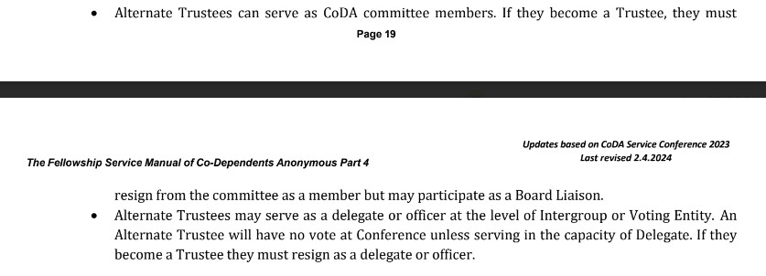

TO:

● Alternate **and Interim** Trustees can serve as CoDA committee members **but cannot simultaneously serve as chair of a standing committee**. If they become a Trustee **or are able to vote at any time**, they must resign from the committee as a member but may participate as a Board Liaison.

● **Alternate and Interim Trustees may not serve as a member of the Issues & Mediation Committee (IMC). The IMC shall remain a neutral party.**

● Alternate **and Interim** Trustees may serve as a delegate or officer at the level of Intergroup or Voting Entity. An Alternate Trustee will have no vote at Conference unless serving in the capacity of Delegate. If they become a Trustee**, or have the ability to vote at any time,** they must resign as a delegate or officer.

**FSM PART 5 Section 3 and CoDA Standing Committees:**

Copy and Paste from most current FSM on coda.org

**FROM:**

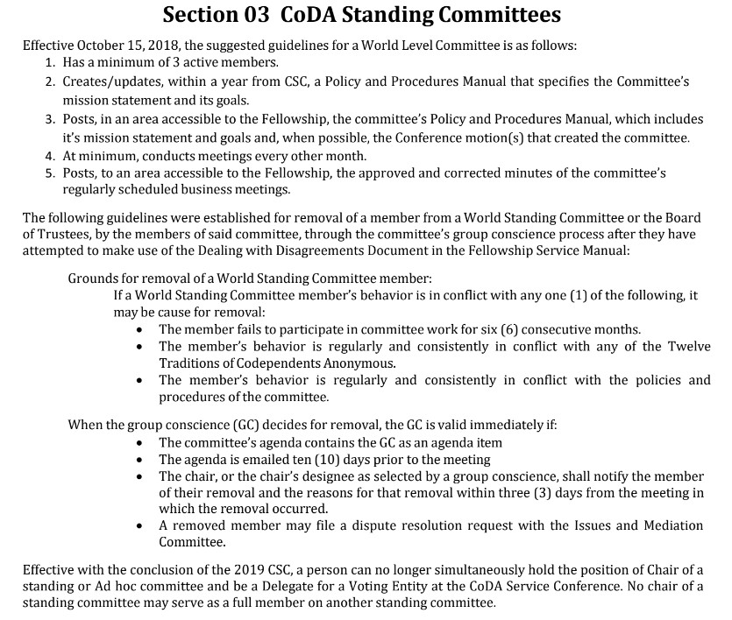

**TO:**

**ADD this verbiage AT END OF SECTION 03 CoDA Standing Committees:**

*Effective with the conclusion of the 2024 CoDA Service Conference (CSC), a chair of a standing committee or any member of the Issues & Mediation Committee (IMC) may not serve as a Board Alternate or Interim Board Member unless they relinquish their position.*

**Motions** are to be sent to:  [**submitcsc@coda.org**](mailto:submitcsc@coda.org)

**Bylaw changes/amendments** are to be sent to:  [**secretary@coda.org**](mailto:secretary@coda.org)

If you want assistance writing your motion, please send email to [Board@CoDA.org](mailto:Board@CoDA.org)

**(Data Entry Use Only)**

**Motion result:**