Proper use of CoDA Registered Trademark Logo’s
CoDA Fellowship Service Manual, Part 1, Section 05, Page 35, Last Revision: 2020-12-22 (for full information)
https://coda.org/wp-content/uploads/FSM-Part-1-Structure-and-General-Information.pdf
This is the CoDA Seal; it is a registered trademark. Use of this mark is only allowed under a Trademark License Agreement, which agreement may allow customization by adding the name of an Intergroup or Voting Entity to the outside perimeter of the seal and/or translation of the words within the circle other than “CoDA”. No other changes are permitted. Please contact Board@coda.org.
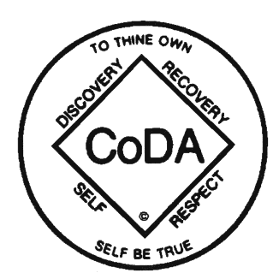
CoDA groups may use the following seals on their letterheads, newsletters, journals, flyers, and other publications. They can be customized with the name of the CoDA organization outside the seals below.
