CoDA Resource Publishing (CoRe) Annual Report

From Q4 2021 – Q2 2022 (June 22)

The CoRe Board conducted monthly business meetings and strategic planning meeting.

2021 Royalties Paid to CoDA

October: $9,355.10,

November: $8,115.22,

December: $20,363.51

Total 4th Qtr: $37,833.84

2021 YTD Royalties Paid: $148,992

2022 Royalties Paid to CoDA as of June 22: $74,289

**Literature Printed and /or Reprinted**

Joy in The Journey, Recovery with Color - First run English

Common Threads – English

12 & 12 Steps & Traditions Workbook - English

12 Steps Handbook - English

Making Choices - English

Tools for Recovery - English

Peeling the Onion - English

Communication & Recovery - English

Joy In The Journey, Recover with Color – Second run English & First run - Spanish

Coins & Medallions Produced

Medallions (Years): 2, 3, 8, 6, 12, 13, 14, 31, & 36

Coins (Months): 2, 3, & 6

**Free Literature Distributed**

30 Starter kits sent

*\*“Starter Kit” is a collection of CoDA endorsed literature which is sent to new (startup) CoDA meetings at no charge.*

**English Electronic Publications (aka EPubs).**

The following publications were converted to electronic publication and submitted to Amazon and iTunes. The links can be found on corepublications.org.

4101 Newcomers Handbook, 4021 Peeling the Onion, 4024 The Twelve-Piece Relationship Toolkit, 4016 Tools for Recovery, and 4103 Twelve Steps Handbook

(The Spanish epubs were created last year and the link can be found on corepublications.org.)

**Quantity Discount for “In This Moment English and Spanish”**

In an effort to reduce individual handling charges, case price discounts have been created.

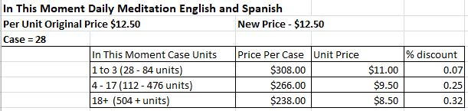

**Reduced Price for CoDA Pocket Blue Book**

The price of the CoDA Pocket Blue Book has been reduced in an effort to stimulate sales. The number of Pocket Blue Books (English) sold per year is about 1,405 units, whereas, the CoDA Blue Book units sold were 8,171. CoRe will evaluate whether or not future price reductions might be helpful.



Policies & Procedure Manual

New submissions under review for version 3.

2022  **Board of Trustees:**

Yvonne K (NorCal) – Chair

Annie S (MA) – Vice Chair

Kathy H (PA) – Treasurer

Addie M (OH) - Trustee

Ritchard I (Canada) – Trustee