CoDA Service Conference 2023 Motion Form
Motion – Spanish Outreach Committee
Submitted Date: _______________________
Due: 75 days prior to CoDA Service Conference (CSC)
Motion Number: 2
Revision #: _____________ Revision Date: _________________
Due: 60 days prior to CoDA Service Conference (CSC)
Motion Name: Allow online sharing of the daily meditation from In This Moment.
Motion: Online groups have long been sharing these meditations during meetings, one day at a time. It is time to recognize this practice as a method of attraction rather than promotion.
Intent, background, other pertinent information: Previous Boards have alternately restricted and allowed the use of segments of CoDA literature in different contexts.
Recently, SPO was advised never to share a copy of a written page of the Daily Meditation, but SPO was simultaneously told that it could record the page and post just the audio. Given the vast number of online meetings (Spanish, English, etc.) that do share the meditation page each day, SPO researched the sales of this item, to see whether sales have plummeted given their daily use online. The numbers reveal that such postings are, in fact, a method of attraction, rather than promotion and that they have not slowed the sale of this item. Rather, such postings have led to greater sales of the book.
The following figures – based, in Mexico’s case, on just four months of sales and in CoDA Colombia’s case, on one year and nine months – show that sales of In This Moment Daily Meditation Book are not depressed, but robust. They compare well with a full three years plus the first quarter of this year’s sales by CoRe:
In This Moment Sales | 2020 | 2021 | 2022 | 2023  (Jan-Mar) | TOTAL
CoRe | 184 | 98 | 151 | 53 | 486
CoDA Colombia |  | 6/21 |  | 3/23 | 405
CoDA Mexico |  |  | 12/1/22 | 5/1/23 | 347

Similarly, SPO shared the daily meditation twice on TikTok, where they were opened 726 and 859 times (see visual, below). When the text was removed, and only a recording of the meditation was posted, visits were fewer: 71. This shows the powerful message the daily meditations convey.
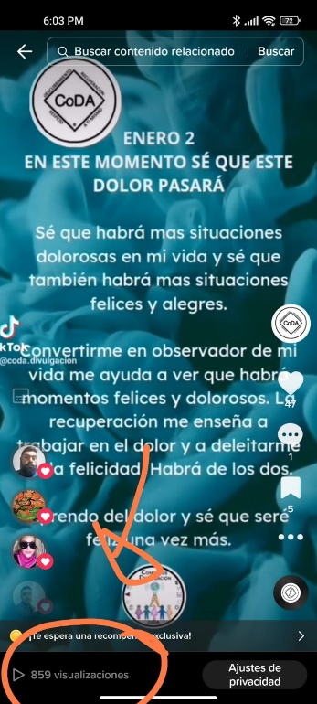
Remarks: With the onset of radio broadcasting, professional sports franchise owners opposed the coverage of games on the radio. Later, they opposed filming the games for TV, on the grounds that it would depress attendance. In fact, professional sports games in the US are consistently highly attended: coverage on radio and TV have not stopped people from going to see games. The owners’ fears of media coverage have been disproven.
CoDA will not lose its copyright through the daily use of a single page from In This Moment, nor will sales of that book decrease.
This motion requires changes to: (please check any that apply)
____ Bylaws ____ FSM P1 ____ FSM P2
____ FSM P3 ____ FSM P4 ____ FSM P5
____ Change of Responsibility ____ Other: _________________
(Data Entry Use Only)
Motion result: _______________________________________

