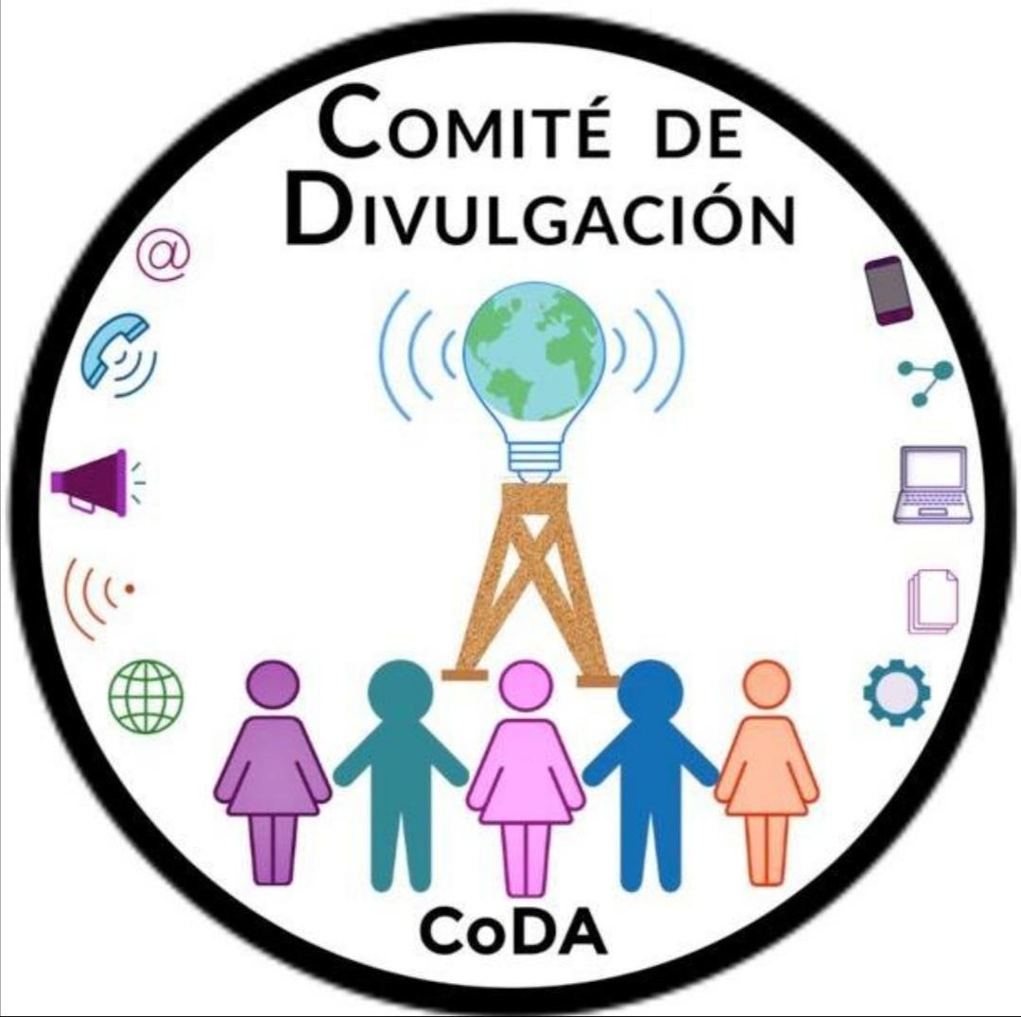
Spanish Outreach (SPO)
Annual Report – July 2022 to July 2023
For most of this year, Spanish Outreach’s activities have been focused on replying to the various emails received daily. The most frequent themes of these queries are how to find a meeting, how to register a meeting and requests for information about literature. We also continue to answer the phone line, following up on them as the needs expressed by callers dictate.
SPO has dedicated itself to posting in such new media sites as TikTok and Instagram. There, we use different types of materials to reach both newcomers and CoDA members as we explain what CoDA is.
On its YouTube channel, SPO provides various offerings that allow CoDA members to share their Experience, Strength and Hope, as in the following:
*Brief Experiences/Breves Experiencias – These are short recordings by members who share their experiences about a particular topic.
*Monthly Forum of Information for Codependents – This involves a speaker for 90 minutes, followed by 15 additional minutes for Q & A on related topics of codependence, as presented by CoDA members.
*Coffee Hour, Enjoying your Company (podcast) – Provides for 90 minutes plus 15 additional minutes for our colleagues to speak about their recovery in an enjoyable and relaxed manner.
*Cinema Forum – Members of the Fellowship share about the particular film short that was shown that month.
*Spanish Outreach’s Annual International Spanish-Speaking CoDA Convention
*Brief snippets of information provided via YouTube Shorts
The above content for each of the social media sites mentioned may be found here:
https://drive.google.com/drive/folders/1ax6G7s81H2qXCZ6cqk16f_HXzcKMOWfh?usp=sharing
The Third International Spanish-Speaking CoDA Convention, “Reconstructing our lives,” was organized and carried out during the first weeks of November 2022.
The Starting Point Project (Un Grano de Arena) continued apace, with the first deliveries of the abbreviated edition of Co Dependents Anonymous (the Blue Book) to CoDA Mexico between September and October of 2022. This was followed in June of 2023 by the delivery of this same title to the Spanish-Speaking Intergroup of Southern California. Deliveries to Spanish language CoDA meetings in Nevada, Texas, Northern California, Washington and Florida as well as CoDA Colombia are pending.
SPO continues to support other CoDA World Committees by publicizing their various events, from the CoDAthon, the Sponsorship Workshop and the CSC 2023, among others.
Several times this year, SPO has worked with CoDA Mexico, CoDA Colombia and the Spanish Speaking Intergroup of Southern California to unify efforts to develop new ways to promptly convey timely information to CoDA members.
The figures below reflect the patterns of visits to the various social media that SPO operates.
SPO’s website Divulgacioncoda.org, 6/1/22 to 6/20/23 (Data from Google Analytics)
Pages: There have been 37,340 visits to the site’s pages. The top 10 pages visited, in descending order, were: Home, Literature, Vuelvo a Sonreír Workshops, CoDAthon, Announcements, Monthly Forum, CoDAteen, Welcome to CoDA, Alternative Meetings, Audio Experiences.
3,910 user clicks to purchase literature from CoRe Publications, Kindle and iTunes.
9, 039 Users visited the site from the following areas, in descending order: Mexico, USA, Spain, Argentina, Colombia, Costa Rica, Uruguay, China, United Kingdom, Canada.
People visited the site using Mobil phones (Android and iPhone): 6,464 and Computers: 3,320 and Tablets: 150
Subscription List – provide News, Announcements and reminders of the Monthly Forum. (Data from Constant Contact)
8 Announcements were sent out. Of these, 71,613 announcements were received, 24,146 were opened and there were 2,604 Clicks through to the links in the Announcements.
There are a total of 784 subscribers.
CoDA Application in Spanish (Data from Google Analytics and Firebase)
This has been downloaded 746 times since it went live on January 12, 2023. Forty messages have been published there; as the number of downloads increases, post openings have grown to 9,943.
Countries where the App was downloaded were, in descending order: Mexico, USA, Colombia, Argentina, Spain, Guatemala, Venezuela, Uruguay, Costa Rica and Brazil.
SPO’s YouTube channel – @Codependientes Anónimos en español (Data from YouTube Analytics)
SPO’s YouTube channel received 31,114 visits in the past year. It has 2,031 subscribers. Visitors came, in descending order, from: Mexico, the US, Colombia, Spain, Argentina, Peru, Costa Rica, Guatemala, Venezuela, Ecuador, Chile, Uruguay, Cuba, Panama, Brazil, the Dominican Republic, Honduras and Paraguay.
TikTok (Data from the App)
SPO began to generate content here in January of 2023, and has produced 30 informative videos, garnering 200 followers.
Instagram (Data from the app)
As with TikTok, the account began by sending out videos at the beginning of January of 2023. Up to now, it has garnered 95 followers. It features 30 videos.
WhatsApp (Data from the App)
This method of transmitting information to the Fellowship debuted on March 23, 2023. After 3 months, there are 120 subscribers. SPO alerts users to CoDA World events in various venues as well as general information about literature. SPO also posts news about other committees’ activities whenever send us a request to broadcast it.
This type of WhatsApp list does not allow members to contact one another or access anyone’s contact information, thereby respecting and safeguarding their anonymity.
Members:
Monica R. (Chair) and Elba A. – Mexico
Adriana A. and Martha Patricia – Colombia
Blanca F. and Linda A. – SoCal
SPO Translation Subcommittee
This Subcommittee has worked continuously to update the coda.org/es website. Nevertheless, updates to the site are significantly hampered by the constant flow of information as well as permanent changes to the site.
The loss of members from the Subcommittee has necessitated dividing up our activities, resulting in a delay that we are rectifying by employing new stratagems.
The Translation Subcommittee has occasionally, when asked to do so, supported CoRe by translating and updating its documents to Spanish.
During the 2022 CSC, the Subcommittee’s goal was to provide timely information about the CSC as it unfolded, as well as to provide background information in the lead up to both the CSC and the ICC. We conveyed that information via the different communication media that SPO operates. Said material may be examined here: https://drive.google.com/drive/folders/1f4H5KRSTqb9n55-6lGGycbTmQ5MIevI5?usp=sharing
Subcommittee Members: Monica R/Mexico (Chair), Linda A/SoCal

