CoDA Service Conference 2023 Motion Form

Check one: __ Motion (Board - CoDA Inc.)
__ Motion (Board - CoRe – CoDA Resource Publishing)
__ Motion (Committee)
Committee Name - _____________________
_X_ Motion Voting Entity
Voting Entity Name: Northern California CoDA - (NorCal CoDA)

Submitted Date: __April 2, 2023_______________
Due 75 days prior to CoDA Service Conference (CSC) by May 1st

Motion Number: 1. () 2. (X) 3. () 4.() 5. () (Check One)
Revision #: _____________ Revision Date: ______________
Due 60 days prior to CoDA Service Conference (CSC)
Motion Name: Committees: Voice and Vote at All Future CSCs
Motion:
To give committee chairs permanent voice & vote and to give committee members permanent voice (not vote) during all future CoDA Service Conferences (CSC).

Intent, background, other pertinent information:
The first intent:
NorCal CoDA seeks to eliminate the lengthy time spent on the first morning of CSC obtaining group conscience to decide whether or not to give voice and vote to committee chairs and voice to their members for that specific service conference. This motion seeks to make this a permanent decision for all future CSCs.

The second intent:
The CoDA committee members work year round for the betterment of the CoDA fellowship. They are knowledgeable about the needs of our CoDA members and what it takes to keep CoDA functioning. They are dedicated trusted servants who deserve to be heard.
Background:
2022 CSC a similar motion, see below, was presented and incorrectly “shut down” and later found to be an “allowable procedural item.”
CoDA By-Laws, Article IV - Membership and Voting, Section 4. Others
“The Conference may extend voice or vote privileges at the Conference to any member of the CoDA Fellowship that it deems appropriate or necessary. Voice or vote may be granted for the entire Conference, or on individual issues. This flexibility is sometimes needed to gain the valuable input and services of members who are not specifically included in the above paragraphs.”

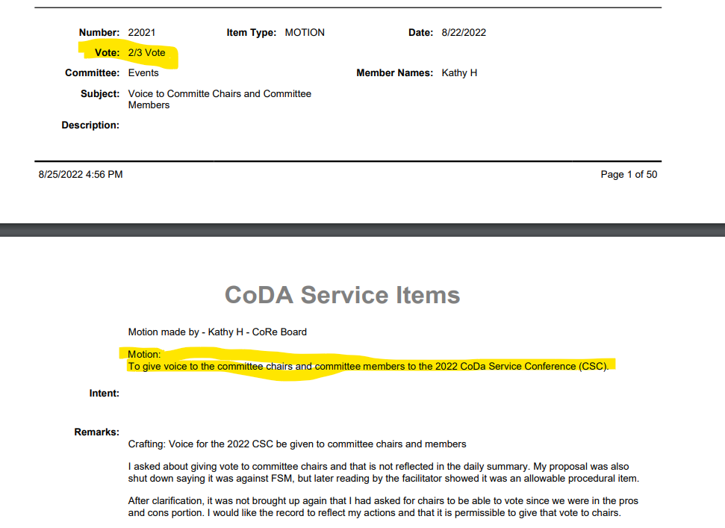
Remarks:
Many thanks go to Kathy H of the CoRe Board who brought this motion in 2022 and all the trusted servants.

This motion requires changes to: (please check any that apply)
_X__ Bylaws (Sect 4) __X__ FSM P1 (page 17) ___ FSM P2
____ FSM P3 ____ FSM P4 ____ FSM P5
____ Change of Responsibility ____ Other

(Data Entry Use Only)

Motion result: _______________________________________

Please email to submitcsc@coda.org
(If you want assistance writing your motion, please send email to Board@CoDA.org)

