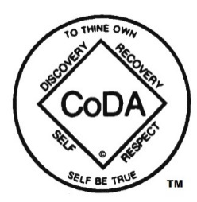

CoDA Board of Trustees
Virtual F2F Board Meeting Minutes
July 18, 2021

Attending: Nancy O/Canada, Don B/SoCal, Barbara/NorCal, Gail S/Nevada, Yaniv S/Israel, Faith J/Canada, Matt T/Texas, Joe R/Guatemala – Partial Attendance

OLD BUSINESS

Minutes Virtual F2F Minutes July 10, 2021-
- Motion: Move to approve the July 10, 2021 minutes. Moved – Barbara, Second – Don, Vote – Yes, Unanimous

Spanish Outreach (SPO) Website Email re July 16, 2021 - Action: Nancy to respond to SPO’s email (cc Board) advising them that they can have whatever time they need to translate the Spanish coda.org/es website before launching it.

Website Printing Solution Mockup – The Board discussed the Printing Solution provided by the website developers.
- Action: Nancy to advise the website developers that we approve going live with the meeting search results printing solution.

NEW BUSINESS

Response to Mexico – Discussed email from Mexico that advised of royalties paid and that requested permission to sell their literature to other countries.
- Action: Nancy to advise Mexico that we will look into their request Post Conference.
- Action: Don will let CoRe know of the request.

Email from IMC re Delegate Verification – Discussed the email from the Voting Entity Liaison regarding alternate meetings delegates.
- Action: Gail to advise the Voting Entity Liaison (VEL) that the Board does not approve the alternate meeting delegate without proof that the delegate selection process has been followed. Gail will also ask VEL to discuss the process followed for last year’s alternate meeting delegates with Florence.

Executive Session Review of CSC Motions – The CSC motions were reviewed and discussed. There were concerns with the Spanish Outreach (SPO) Motion.
- Motion: That Matt draft an email to SPO asking them to withdraw their motion, and the Board will take further action on it. Move – Don, Second – Nancy, Yes – Unanimous

Next Virtual F2F or Workgroup Meeting – July 24, 2021 at 8:00 am Pacific time

